**Arkansas Movie Database Website Project Analysis**

Sponsor: Thomas Wallace

Rukshar Parwin

University of Arkansas Little Rock

IFSC 3330: Capstone I

12-13-2020

**Table of Contents**

Client Introduction/ Organizational Background 3

Analysis 3

Design & Development Work Performed 3

Search 3

Movie Details 5

Professional Responsibilities 5

Assumptions 6

Summary Milestone Schedule 6

# Client Introduction/ Organizational Background

The project is an attempt to serve a need of having a central website to help support Arkansas talent and showcase details around Arkansas landscape and opportunities for filmmakers.

Each of the filmmakers who are interested in filmmaking in Arkansas depends on external sources to understand the landscape, movies that were shot here, and the actors who have ties to Arkansas. Filmmakers usually have high investments in this kind of project, and they may be interested to find out details on the location, incentive they may be able to get etc. Absence of central website promoted by Arkansas Film Commission makes this process costly and inefficient – and the information they may collect are prone to error. This can cost state of Arkansas unrealized revenue that it may lose and the potential job creation for the local talents in the state of Arkansas

# Analysis

The website will offer state-of-the-art navigation page, collecting movies data that has ties to Arkansas and centralizing it for design flexibility. According to Mark Smallcombe, writing for Xplenty website (<https://www.xplenty.com/blog/top-5-reasons-to-centralize-data/>), top 5 reasons for a business or organization to centralize data of their interest are 1) Helps optimize Data Assets, 2) Enhanced Consistency, 3) Focus on What’s Important, 4) Enhanced Customer Experience, 5) Saves Time and Money.

# Design & Development Work Performed

## Search

This functionality is used to search the movie details. Once a user enters the search keyword and clicks on the search button the search results can be shown.

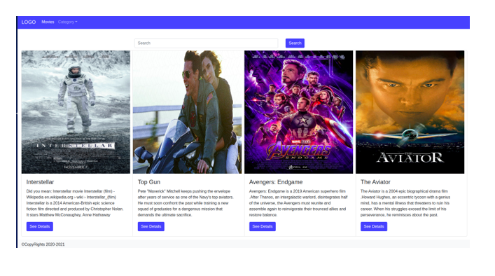

## Movie Details

This page is used to show the details of a movie.

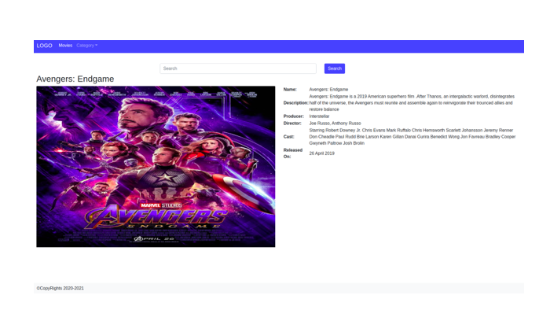

# Professional Responsibilities

The website will be designed keeping in mind that it is intended to provide research kind of platform to understand diversity of landscape. Unifying feature of users will be people interested in films in AR. The website will include Arkansas Film Commission contact information for enquiry about filmmaking in Arkansas and potential incentive. By having direct access to all the data and contact information, any potential user can more efficiently verify, fulfill, and get information about this project.

# Assumptions

Here is the list of assumptions in this project

* The data captured in themovedb.org is accurate.
* The data captures all the information related to actor, actress, and location with ties to Arkansas.

# Summary Milestone Schedule

|  |  |
| --- | --- |
| **Summary Milestone Schedule** | |
| **Project Milestone** | **Target Date (mm/dd/yyyy)** |
| 1. Project Start | 09/23/2020 |
| * Data Source identification | 10/31/2020 |
| * Prototype | 12/05/2020 |
| * Complete Solution | 05/01/2021 |
| 1. Deploy Solution | 05/01/2021 |
| 1. Project Complete | 05/15/2021 |